**DAILY ONLINE ACTIVITIES SUMMARY**

|  |  |  |  |  |  |  |  |
| --- | --- | --- | --- | --- | --- | --- | --- |
| **Date:** | **04/06/2020** | | | | **Name:** | **Anusha. K** | |
| **Sem & Sec** | **4th SEM 'A' Section** | | | | **USN:** | **4AL18CS009** | |
| **Online Test Summary** | | | | | | | |
| **Subject** | | **Microcontroller and embedded systems** | | | | | |
| **Max. Marks** | | **20** | | **Score** | | **14** | |
| **Certification Course Summary** | | | | | | | |
| **Course** | **Introduction to full stack development** | | | | | | |
| **Certificate Provider** | | | **greatlearning academy** | **Duration** | | | **2.3 hours** |
| **Coding Challenges** | | | | | | | |
| **Problem statement 1:**write a java program to read three integer values from the keyboard and find the sum of the values. Declare a variable “sum” of type int and store the result in it.  **Problem statement 2:Write a C++ program to find the missing number in array** | | | | | | | |
| **Status: completed** | | | | | | | |
| **Uploaded the report in Github** | | | | **yes** | | | |
| **If yes Repository name** | | | | [**https://github.com/anusha20219/Lockdown-coding**](https://github.com/anusha20219/Lockdown-coding) | | | |
| **Uploaded the report in slack** | | | | **yes** | | | |

ONLINE TEST DETAILS: MES test was scheduled from 02:00 pm to 02.30pm .The portion for the IA was 3rd module there were 20 questions and the time assigned was 30 minutes.The questions were mcq type.

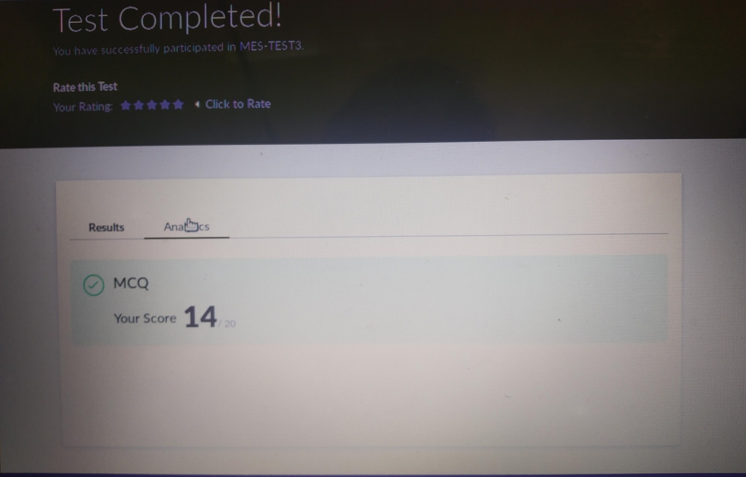

CERTIFICATION COURSE DETAILS: **Today I completed data visualization using python certification course and then took up introduction to full stack development. I learnt about introduction to front end, html structure, paragraph and heading tags.**

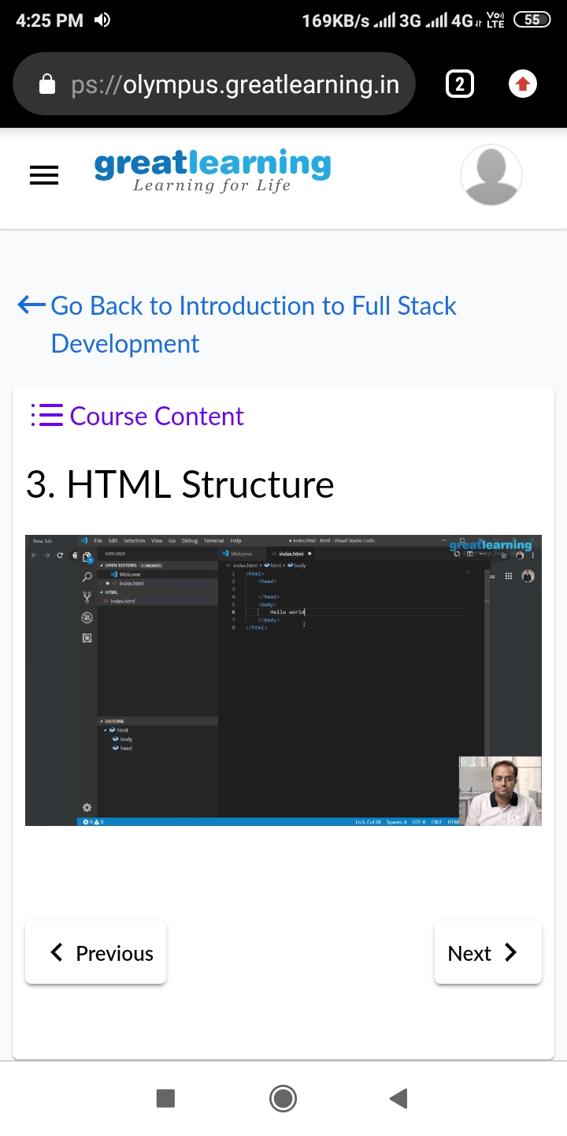

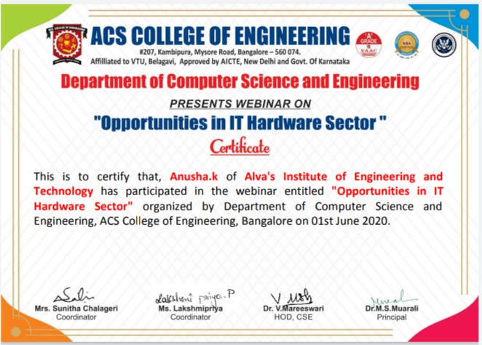

**CODING CHALLENGES DETAILS**

**Problem statement 1: write a java program to read three integer values from the keyboard and find the sum of the values. Declare a variable “sum” of type int and store the result in it.**

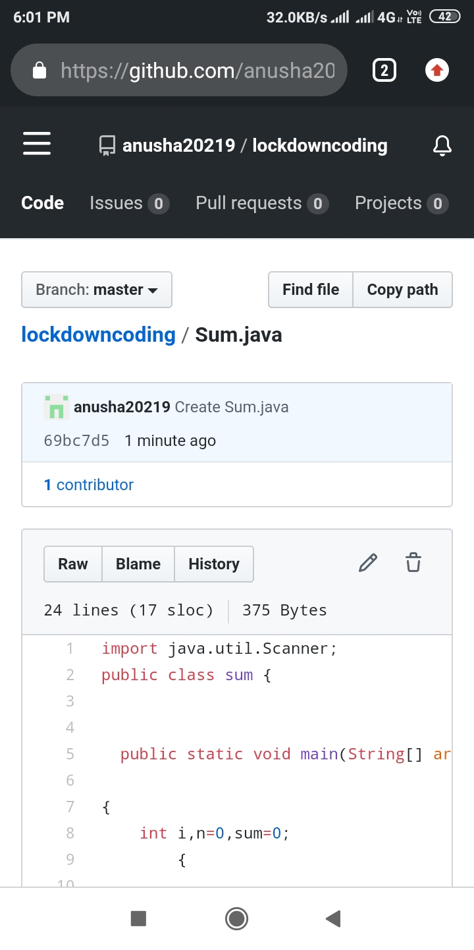

**Problem statement 2 :Write a C++ program to find the missing number in array.**

